The Unofficial Castle Ravenloft - Talespire Edition Kickstarter
By Virtual Tabletop Journey
My company, Virtual Tabletop Journey, is helping new and veteran players experience the Curse of Strahd campaign like they never have before, by professionally re-creating the iconic locations within the 3D virtual tabletop program - Talespire.

All of our work falls under the Wizard of the Coast Fan Content policy as it is freely available for everyone! They have reviewed our project and agree we are good to go!

For nearly two years we have been creating these premium maps as a hobby, now we want to fund a collaborative effort between all the professional builders.

We are super excited about our Kickstarter and we hope you find it interesting enough to share with your audience! Here are some items you might like to look at.

Videos & Examples of our Maps

- Kickstarter Project Video
- Death House - Talespire Edition Trailer
- Amber Temple - Talespire Edition Trailer

Links
- Our Castle Ravenloft Kickstarter page
  - Please send folks here to sign up!
- Talestavern profile page
  - With all the free content we have released to the community.
- The Talespire VTT at Steam
- Our Patreon, where we publish monthly 5e Adventures with game ready Talespire resources
Files
- 5e Adventure - Mystery in Bludmist Swamp - FREE!
  - At DropBox
  - At DriveThruRPG

Images & Info
- A media resources page has been created, just for you!

Email Template - Live
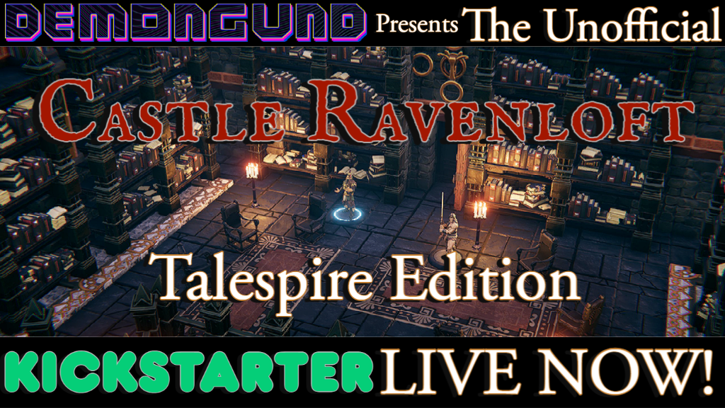

Castle Ravenloft + Talespire Kickstarter!

Free For Everyone!

Dear Members,
John (Demongund) and Tony (Heimdahlr) over at Virtual Tabletop Journey are launching the long awaited Castle Ravenloft - Talespire Edition Kickstarter! They have already created iconic maps such as the Bonegrinder Windmill, Werewolf Den, Death House and Amber Temple, now they need your support to bring Castle Ravenloft to life in 3D!

With these Talespire maps, your gaming group is just a few clicks away from beginning your Curse of Strahd epic. All maps are designed for ease of use and quick map transitions, spend less time doing setup and more on glorious combat… I mean roleplay!
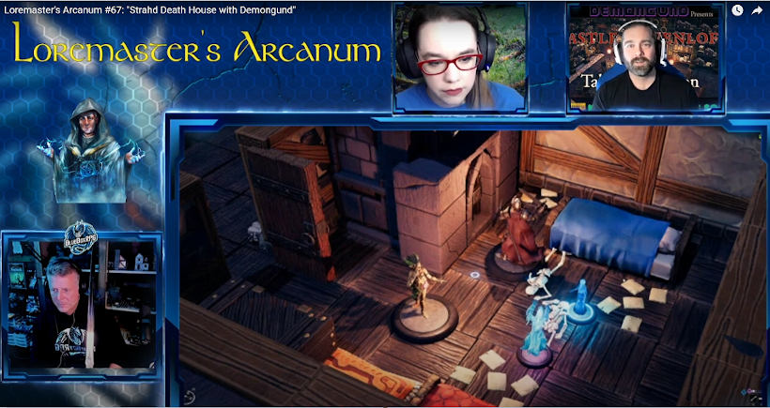

Death House, showcased on the BlueBoxRPG stream.

In addition to the Castle Ravenloft map, the Kickstarter will feature 5e Adventures PDFs! These 20 page modules contain gorgeous 2D resources and also have fully complete Talespire maps!

FREE 5e Adventure - To celebrate the Kickstarter, the Mystery in Bludmist Swamp 5e Adventure will be free to download during the campaign!
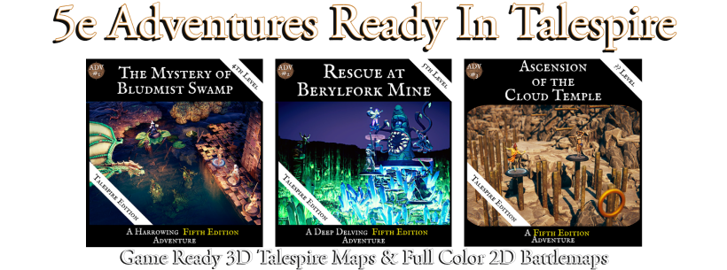

The Castle Ravenloft Talespire map will be published at Talestavern for everyone and there are also great rewards, stretch goals and add-ons, including:
- 5e Adventure PDFs, complete with Talespire support
- Additional Curse of Strahd Talespire maps such as…
  - Argynvostholt, City of Villaki, Van Richten’s Tower
- A custom two-shot adventure through Death House with up to five of your friends

Pledge now to bring Castle Ravenloft to life in 3D!

